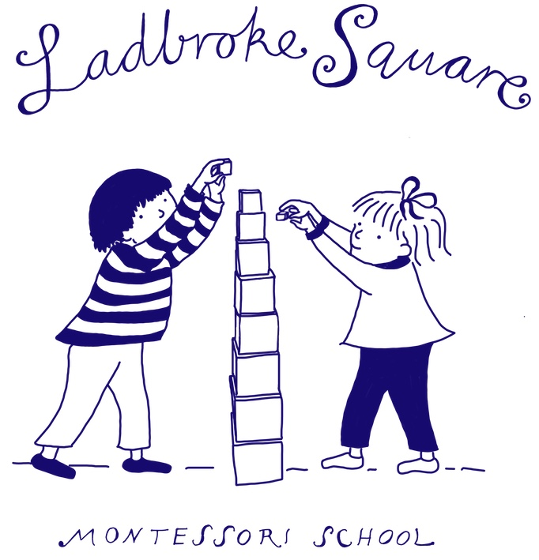 |  |  |  | Ladbroke Square Montessori School
Child’s Surname
First Name |  |  |  |  |  |  |  | Preferred Name
Date of Birth | Day |  | Month |  |  | Year |  | Please select | Girl | Boy
Desired Entry Term |  |  |  |  |  |  |  | Nationality
Languages Spoken at Home
Home Address & Postcode
Telephone Number
Parent 1 full Name (and title)
Home Telephone Number |  |  |  |  |  |  |  | Mobile Number
Email
Home Address (if different)
Parent 2 full Name (and title)
Home Telephone Number |  |  |  |  |  |  |  | Mobile Number
Email
Home Address (if different)
Any special needs relating to your child: health, allergies, culture, language, religion
Please let us know how you heard of Ladbroke Square

Conditions of entry
- Fees are payable in advance at commencement of each term
- A full term’s written notice is required before taking a pupil out of school; otherwise parents are liable for fees in lieu of notice.
- A full term’s written notice must be given for the deposit to be returned.

Please return this form with the non-refundable registration fee of £100 to the school office. Payments can be made by either: -
BACS (with your child’s name as a reference): KATEVA Management ltd  acc: 80021377 Sort code 20-47-47 |  |  |  |  |  |  |  | Cheque made payable to:  LADBROKE SQUARE MONTESSORI SCHOOL
Signature

Office Use Only
Registration Fee Received |  |  |  |  |  |  |  | Deposit Request Date
Entry Term/Year |  |  |  |  |  |  |  | Deposit Received
Place Taken up

By registering my child, I agree to LSMS collecting and holding my data in accordance with the school privacy notice.

In line with GDPR regulations, LSMS will hold all data securely.

If you do not respond to an official place offer letter after 21 days, we will destroy any data held by the school.

Please sign and date indicating you agree to the school holding and processing your data.

Parent 1, Name……………………………………………………………………………..

Signature…………………………………………………………… date…………………

Parent 2, Name……………………………………………………………………………..

Signature…………………………………………………………… date…………………

