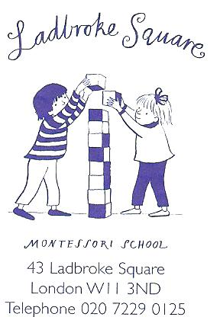
Ladbroke Square Montessori School Guidelines
Timekeeping -
For us to be able to run the school efficiently and for the children to get the most from the classes it is very important that your child arrives at school and is collected from school on time.

School times are as follows – Basement – 9.10am-12.10pm
Ground – 8.55am-11.55am
First Floor – 9.00am-12.00 noon
Top Floor – 9.15am-12.15pm

On Fridays if your child is not staying for ballet or lunch they should be collected at 12.00 noon.
Full Day Children to be collected at 3pm.

Absenteeism -
If your child is going to be absent from school it is very important for you to telephone the school office before 9.00am for morning children to let us know. It is also very important for you to leave a message on the answering machine if your call is not answered. The message will be picked up and the information will be passed on to the teacher.

Health -
It is very important that you inform the office if you suspect your child has Chicken pox or Measles. Likewise we need to know if your child has come into contact with anyone who might have Chicken pox or measles.

Child Collection -
If your child is to be collected by someone other than yourself or his/her nanny please let the office know immediately. We work with a password system, so the office and the person collecting your child should know your chosen password.

Food in School -
We request that your child bring in a piece of fruit or vegetable for his/her break each day.

No items of food containing nuts and sesame are allowed in school. This includes peanut butter sandwiches and any foods containing pesto or houmous.

You might want to include an icepack in your child’s lunchbox as we are unable to put lunchboxes into the school refrigerator.

Your child is welcome to bring in a nut-free birthday cake to share with friends when it is their birthday.

General School Guidelines -
On the last day of each term your child may come to school in fancy dress. Please do not allow your child to come to school in costume at any other time.

We have ‘Show & Tell’ each week. You will need to consult your child’s teacher for which day of the week this is. This is the only time that we allow items to come from the home and into school. We encourage the children to bring in an item that is educational as well as fun!

Double parking must be avoided at all times; it is dangerous and inconsiderate. It is highly likely that a ticket will be issued if a traffic warden finds you illegally parked.

All smocks, coats, shoes, ballet shoes, boots and jumpers must be clearly named before coming into school.

When warm weather bestows itself upon us please remember to put sunscreen on your child before coming to school. We shall apply additional sunscreen unless pre-warned of a possible allergy.

If your child is still a little unsure of his/her toilet training please do not send them to school dressed in clothing such as dungarees, belts etc. We want to be there to help them as much as we can in this area and ask that this job be kept as simple as possible.

Should you wish to make an appointment to see Lucy please contact the office between the hours of 8.30am – 1.00pm.

Parents are welcome to come and observe their child in the classroom. Please make a suitable time with their teachers before doing so.

We would be grateful if parents/nannies did not stay in the classroom chatting to each other as it delays the start of the class.

You are very welcome, during school opening hours, to view the policies and procedures under which the school runs. They are available to you in the school office at any time.

Change of Circumstances -
Should your circumstances change, such as telephone number, change of address etc please could you inform the office as soon as possible so we are still able to contact you easily if your child becomes ill or need you.
Also, it might be useful for us to be aware of personal family changes so we can support the child and family if we need to. Very often children display different behaviours when their routine is changed and it helps us to understand and provide books and special circle times to help them through it.

