Special Educational Needs and Disabilities Policy

Deputy Head: Lucy Morley Telephone: (020) 7229-0125
Deputy Head: Vanessa Dempsey: (020) 7229-0125
or Email: welcome@ladbrokesquarenursery.com
Next date of Annual Review: April 2023

EYFS: 1.1 – 1.17, 2.1 – 2.6, 2.9-2.14, 3.1 – 3.8, 3.45-3.47, 3.53 – 3.54, 3.65, 3.68, 3.69, 3.80.

This policy has been created with regard to:

- The SEND Code Of Practice 2015
- Children and Families Act 2014 (Part 3)
- Equality Act 2010
- Working Together to Safeguard Children (2018)
- Statutory Framework for the EYFS (2021)

Special Educational Needs and Disability (SEND) code of practice.
The nursery has regard to the statutory guidance set out in the Special Educational Needs and Disability code of practice (DfE 2015) to identify, assess and make provision for children’s special educational needs.

At Ladbroke Square Montessori School, we use the SEND Code of Practice (2015) definition of Special Educational Needs and Disability:

A child or young person has SEN if they have a learning difficulty or disability which calls for special educational provision to be made for him or her.

A child of compulsory school age or a young person has a learning difficulty or disability if he or she:
- has a significantly greater difficulty in learning than the majority of others of the same age, or
- has a disability which prevents or hinders him or her from making use of facilities of a kind generally provided for others of the same age in mainstream schools or mainstream post-16 institutions.

Statement of intent
At Ladbroke Square Montessori School, we are committed to the inclusion of all children. All children have the right to be cared for and educated to develop to their full potential alongside their peers through positive experiences, to enable them to share opportunities and experiences and develop and learn from each other. We provide a positive and welcoming environment where children are supported according to their individual needs and we work hard to ensure no children are discriminated against or put at a disadvantage as a consequence of their needs. Each child’s needs are unique, therefore any attempt to categorise children is inappropriate.

We are committed to working in partnership with parents in order to meet their child’s individual needs and develop to their full potential. We are committed to working with any child who has a specific need and/or disability and making reasonable adjustments to enable every child to make full use of the nursery’s facilities. All children have a right to a broad and well-balanced early learning environment.

We will undertake a Progress Check of all children at age two in accordance with the Code of Practice and Statutory Framework for the EYFS.

We will also undertake an assessment at the end of the Early Years Foundation Stage (in the final term of the year in which a child turns five) to prepare an EYFS Profile of the child.

We will work closely with the child’s parents and any relevant professionals to establish if any additional action is required. This may include:

- Liaising with the child’s parents and, where appropriate, the child
- Liaising with any professional agencies
- Reading any reports that have been prepared
- Attending any review meetings with the local authority/professionals
- Observing each child’s development and monitoring such observations regularly.

All children will be given a full settling in period when joining the nursery according to their individual needs.

We will:
- Recognise each child’s individual needs and ensure all staff are aware of, and have regard for, the Special Educational Needs Code of Practice

- Ensure that all children are treated as individuals/equals and are supported to take part in every aspect of the nursery day according to their individual needs and abilities

- Include all children and their families in our provision

- Identify the specific needs of children with special educational needs and/or disabilities and meet those needs through a range of strategies

- Ensure that children who learn at an accelerated pace e.g. gifted and talented children are also supported

- Encourage children to value and respect others

- Provide well informed and suitably trained practitioners to help support parents and children with special educational difficulties and/or disabilities

- Develop and maintain a core team of staff who are experienced in the care of children with additional needs and identify a Special Educational Needs and Disabilities Co-ordinator (SENCO) who is experienced in the care and assessment of children with additional needs. Staff will be provided with specific training relating to SEND and the SEND Code of Practice

- Monitor and review our practice and provision and, if necessary, make adjustments, and seek specialist equipment and services if needed

- Challenge inappropriate attitudes and practices

- Promote positive images and role models during play experiences of those with additional needs wherever possible

- Celebrate diversity in all aspects of play and learning.

- Work in partnership with parents and other agencies in order to meet individual children's needs, including the education, health and care authorities, and seek advice, support and training where required

- Share any statutory and other assessments made by the nursery with parents and support parents in seeking any help they or the child may need

Our nursery Special Education Needs and Disabilities Co-ordinators (SENCO) is Ana Denucci

The role of the SENCO in our setting includes:
- ensuring all practitioners in the setting understand their responsibilities to children with SEN and the setting’s approach to identifying and meeting SEN

- advising and supporting colleagues

- ensuring parents are closely involved throughout and that their insights inform action taken by the setting

- liaising with professionals or agencies beyond the setting

- taking the lead in implementing the graduated approach and supporting colleagues through each stage of the process.

We will:
- Designate a named member of staff to be the SENCO and share their name with parents

- Have high aspirations for all children and support them to achieve to their full potential

- Develop respectful partnerships with parents and families

- Ensure parents are involved at all stages of the assessment, planning, provision and review of their child's care and education and where possible include the thoughts and feelings voiced by the child

- Signpost parents and families to our Local Offer in order to access local support and services

- Undertake formal Progress Checks and Assessments of all children in accordance with the SEND Code of Practice January 2015

- Provide a statement showing how we provide for children with special educational needs and/or disabilities and share this with staff, parents and other professionals

- Ensure that the provision for children with SEN and/or disabilities is the responsibility of all members of staff in the nursery through training and professional discussions

- Set out in our inclusive admissions practice on how we meet equality of access and opportunity

- Make reasonable adjustments to our physical environment to ensure it is, as far as possible suitable for children and adults with disabilities using the facilities

- Provide a broad, balanced, aspirational early learning environment for all children with SEN and/or disabilities and differentiated activities to meet all individual needs and abilities

- Liaise with other professionals involved with children with special educational needs and/or disabilities and their families, including transition arrangements to other settings and schools. (See our transitions policy).

- Use the graduated response system to assess, plan, do and review to ensure early identification of any SEND

- Ensure that children with special educational needs and/or disabilities and their parents are consulted at all stages of the graduated response, taking into account their levels of ability

- Review children’s progress and support plans every 4 weeks and work with parents to agree on further support plans

- Provide privacy of children with special educational needs and/or disabilities when intimate care is being provided

- Raise awareness of any specialism the setting has to offer, e.g. Makaton trained staff

- Ensure the effectiveness of our SEN/disability provision by collecting information from a range of sources e.g. additional support reviews, Education and Healthcare (EHC) plans, staff and management meetings, parental and external agencies’ views, inspections and complaints. This information is collated, evaluated and reviewed annually

- Provide a complaints procedure and make available to all parents in a format that meets their needs e.g. Braille, audio, large print, additional languages

- Monitor and review our policy and procedures annually.

Effective assessment of the need for early help
We are aware of the process for early help and follow the following procedure:

Local agencies should work together to put processes in place for the effective assessment of the needs of individual children who may benefit from early help services. Children and families may need support from a wide range of local agencies. Where a child and family would benefit from coordinated support from more than one agency (e.g. education, health, housing, police) there should be an inter-agency assessment. These early help assessments, such as the Common Assessment Framework, should identify what help the child and family require to prevent needs escalating to a point where intervention would be needed via a statutory assessment under the Children Act 1989.

The early help assessment should be undertaken by a lead professional who should provide support to the child and family, act as an advocate on their behalf and coordinate the delivery of support services. The lead professional role could be undertaken by a General Practitioner (GP), family support worker, teacher, health visitor and/or special educational needs coordinator. Decisions about who should be the lead professional should be taken on a case by case basis and should be informed by the child and their family.

For an early help assessment to be effective:
- The assessment should be undertaken with the agreement of the child and their parents or carers. It should involve the child and family as well as all the professionals who are working with them;

- A teacher, GP, health visitor, early years’ worker or other professional should be able to discuss concerns they may have about a child and family with a social worker in the local authority. Local authority children’s social care should set out the process for how this will happen; and…

- If parents and/or the child do not consent to an early help assessment, then the lead professional should make a judgement as to whether, without help, the needs of the child will escalate. If so, a referral into local authority children’s social care may be necessary.

If at any time it is considered that the child may be a child in need as defined in the Children Act 1989, or that the child has suffered significant harm, or is likely to do so, a referral should be made immediately to local authority children’s social care. This referral can be made by any professional. Working together to safeguard children 2018

Graduated Approach
We follow the SEND Code of Practice (2015) recommendation that, in addition to the formal checks above, nurseries should adopt a graduated approach to assessment and planning, led and coordinated by a SENCO. Good practice of working together with parents, and the observation and monitoring of children’s individual progress, will help identify any child with special educational needs or disability This graduated approach will be led and coordinated by the SENCO and appropriate records will be kept according to the Code of Practice.

Assess
In identifying a child as needing SEN support, the key person, working with the SENCO and the child’s parents, will carry out an analysis of the child’s needs. This initial assessment will be reviewed regularly to ensure that support is matched to need. Where there is little or no improvement in the child’s progress, more specialist assessment may be called for from specialist teachers or from health, social services or other agencies beyond the setting. Where professionals are not already working with the setting, the SENCO will contact them, with the parents’ agreement.

Plan
Where it is decided to provide SEN support, and having formally notified the parents, the key person and the SENCO, in consultation with the parent, will agree the outcomes they are seeking, the interventions and support to be put in place, the expected impact on progress, development or behaviour, and a clear date for review. Plans will take into account the views of the child.

The support and intervention provided will be selected to meet the outcomes identified for the child, based on reliable evidence of effectiveness, and provided by practitioners with relevant skills and knowledge. Any related staff development needs should be identified and addressed. Parents will be involved in planning support and, where appropriate, in reinforcing the provision or contributing to progress at home.

Do
The child’s key person will be responsible for working with the child on a daily basis. With support from the SENCO, they will oversee the implementation of the intervention agreed as part of SEN support. The SENCO will support the key person in assessing the child’s response to the action taken, in problem solving and advising on the effective implementation of support.

Review - The effectiveness of the support and its impact on the child’s progress will be reviewed in line with the agreed date. The impact and quality of the support will be evaluated by the key person and the SENCO in full consultation with the child’s parents and taking into account the child’s views. Information will be shared with parents about the impact of the support provided.

Assess - The key person works with the setting SENCO and the child’s parents and brings together all the information, then analyses the child’s needs.
Plan - The key person and the SENCO will agree, in consultation with the parent, the outcomes they are seeking for the child, the interventions and support to be put in place, the expected impact on progress, development and behaviour and finally a date for review.

Do - The child’s key person implements the agreed interventions or programmes
Review - On the agreed date, the key person and SENCO working with the child’s parents, and taking into account the child’s views, will review the effectiveness of the support and the impact of the support on the child’s progress. They will then evaluate the impact and quality of support on the child.

Education and Health Plan (EHC)
Some children and young people may require an EHC needs assessment in order to decide whether it is necessary to develop an EHC plan. The purpose of an EHC plan is to make adjustments and offer support to meet the special educational needs of the child, to secure the best possible outcomes for them across education, health and social care.
The local authority will conduct the EHC needs assessment and take into account a wide range of evidence, including

- evidence of the child’s developmental milestones and rate of progress

- information about the nature, extent and context of the child’s SEN

- evidence of the action already being taken by us as the early years provider to meet the child’s SEN

- evidence that, where progress has been made, it has only been as the result of much additional intervention and support over and above that which is usually provided

- evidence of the child’s physical, emotional and social development and health needs, drawing on relevant evidence from clinicians and other health professionals and what has been done to meet these by other agencies.

We will then work with the local authority and other bodies to ensure that the child receives the support they need to gain the best outcomes.

This policy was adopted on | Signed on behalf of the nursery | Date for review
5th April 2022 | 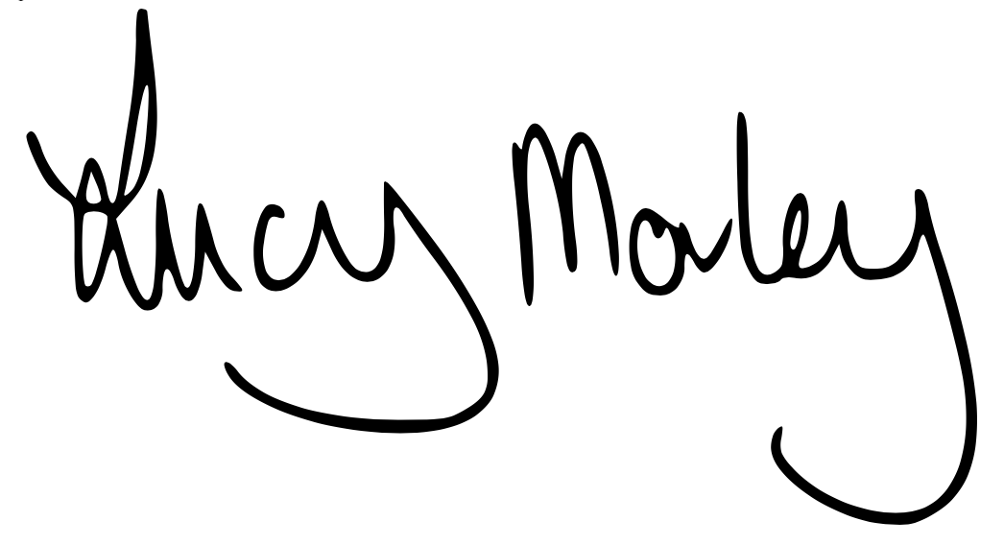 | April 2023
Taken from NDNA Safeguarding Template 2022/23

